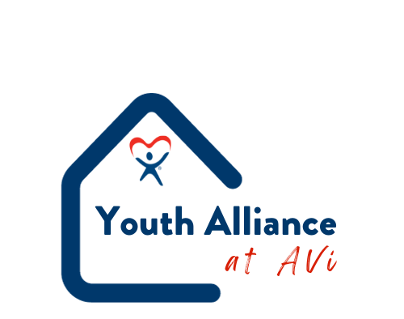

Community Resources
Mental Health
- Jefferson Center/CO Crisis
  - Call 844-493-8255 or Text TALK to 38255
  - 4643 Wadsworth Blvd
  - www.jcmh.org
- National Suicide Prevention
  - Call 303-692-2539 or Text HOME to 741741
  - www.coosp.org
- Trevor Project for LGBTQ+ Youth
  - Call 866-488-7386
- Safe to Tell
  - Anonymously report threats and concerns
  - Call 877-542-7233
- Assault Hotline
  - Call 303-322-7273
- OK to Talk
  - Teens sharing
  - Call 800-273-TALK
- Love is Respect
  - Dating abuse/unhealthy relationships
  - Call 866-331-9474
- National Institute of Mental Health
  - www.nimh.hih.org
- ManTherapy.org

Housing
- Heading Home
  - www.headinghomejeffco.com
- Severe Weather Shelter Network
  - www.swshelternetwork.com
Foster Care
- Collaborative Foster Care Program
  - www.collaborativefostercare.com
Tools
- The Bridge at Revive Church
  - www.thebridgearvada.org
- Care Portal
  - www.careportal.org
- MyFriendBen
  - www.myfriendben.org
- Community Resources in Jeffco
  - www.jeffco.us/4019

